**7-3 Project Two: System Design Document**

Patrick S. Coyne

Global Campus, Southern New Hampshire University

CS 255: System Analysis and Design

Instructor: Dr. Aline Yurik

October 19, 2025

# CS 255 System Design Document Template

## UML Diagrams

### UML Use Case Diagram

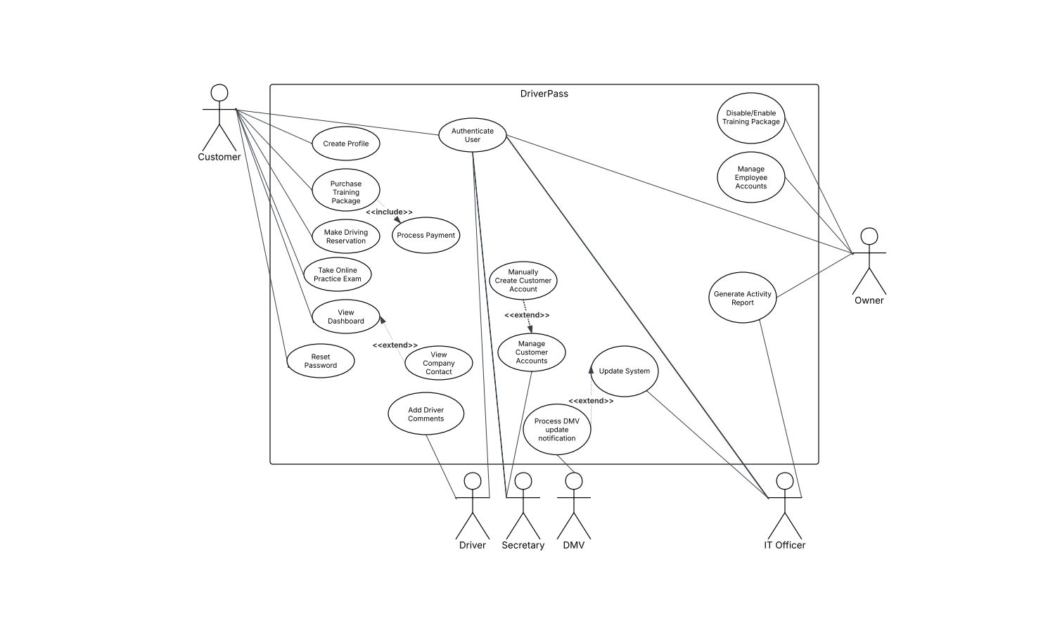

### UML Activity Diagrams

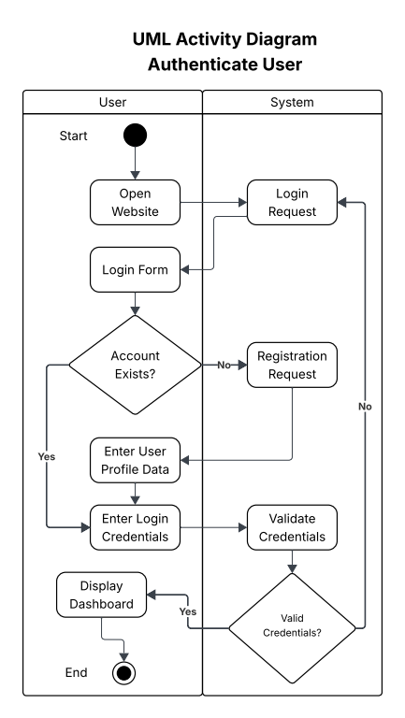

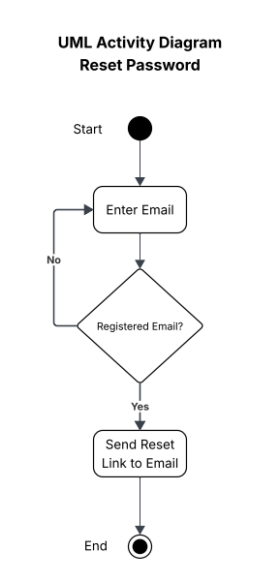

### UML Sequence Diagram

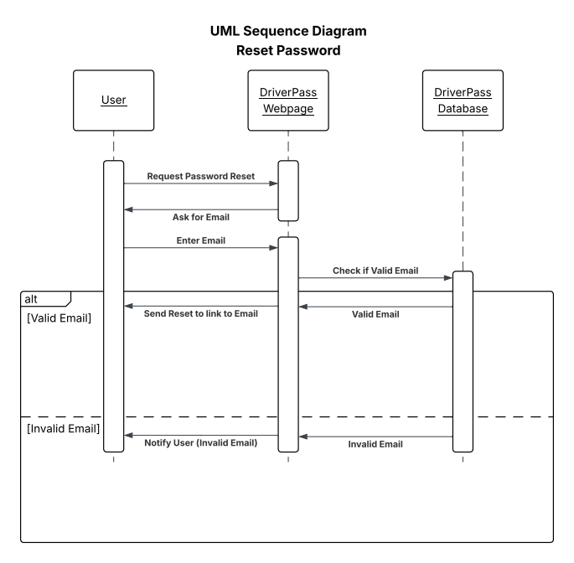

### UML Class Diagram

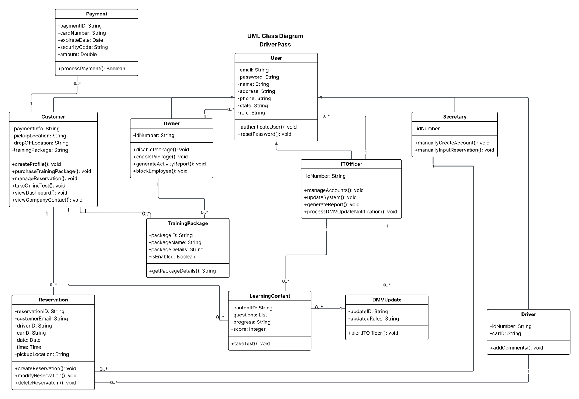

## Technical Requirements

### *Hardware*

The DriverPass system requires a hardware setup centered around a cloud-based server infrastructure hosted on Amazon Web Services (AWS). The AWS server hardware will perform well enough to ensure smooth operation under a load of 40 simultaneous users, maintaining response times within 3 seconds. Backup hardware is managed by AWS services, eliminating the need for on-premises solutions.

### Software

Software for the DriverPass system includes a Linux-based operating system on the AWS server. A relational database management system is required to store and manage user profiles, reservations, and training packages. Lastly, an API client library is necessary to integrate with the assumed DMV API for real-time updates.

### Tools

Development of the DriverPass system requires an Integrated Development Environment (IDE) such as Visual Studio Code, which is recommended for coding the web application. Deployment is facilitated by AWS and the AWS Management Console for managing cloud resources.

### Infrastructure

The infrastructure for the DriverPass system is built on AWS to provide a scalable, web-based solution. The AWS setup includes virtual servers to run the application, a database to store information, and storage for files like reports. Backup and recovery are handled automatically by AWS. An easy-to-use connection point manages updates from the DMV and internal tasks, and a traffic manager balances user load to keep the system running smoothly as more people use it.